Report to The People
Lincoln County 2022

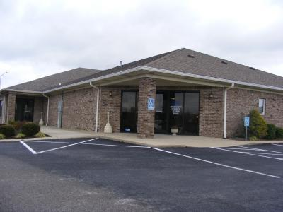
Lincoln County Extension Office
104 Metker Trail Stanford KY 40484
606-365-2447
Lincoln.ca.uky.edu

One interesting fact about Lincoln County is that we are home to the first brick house in Kentucky. This being the William Whitley House that still stands today.

Agriculture and Natural Resources Program

Each year the county receives funds to help farmers with on farm advancements. The ANR Extension program is largely involved with this program as there is an educational requirement everyone must complete. The educational component is handed to Extension to see that each person has an opportunity to participate. I have been utilizing the local drive-in to educate those individuals participating in the program. With such a large crowd, we can not fit into the office meeting rooms, so we have moved it outside! Cattleman’s cooked for everyone, and the concession stands were open for business selling the best soft serve ice cream in town. We had a raffle that night as well, and the winner went home with a brand new grill! 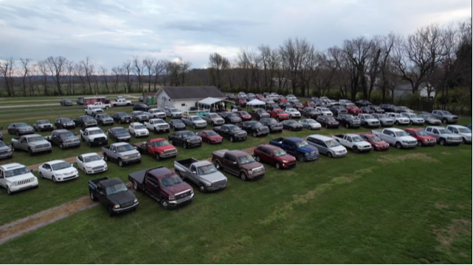

Over 200 people in attendance!
Success Story Highlight
Success Story Title: Bring on the Popcorn!

Family and Consumer Sciences
The Family and Consumer Science groups are all very active. From Quilting to exercising and everything in between. This was a big year for this program area as membership grew and testing of new pilot programs. We cannot forget to mention that the Lincoln County Homemakers served as the host for the Area Homemakers Annual Meeting. This year’s Annual Meeting was well attended with Homemakers from all across the area. The theme was fun and exciting as all were dressed in their favorite Hawaiian textiles. The Lincoln County Cattleman’s provided a mouth watering brisket dinner. It must have been good, as there were no leftovers!
82 Homemakers attended the Annual Meeting!

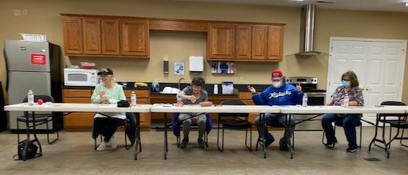

Bingocize was a hit! There is no doubting that. Participants loved playing bingo and learning new exercise moves, sign language, and having special guests call out the numbers from time to time, all while listening to hit music like the Beach Boys! With so much fun to be had, the group started to outgrow the meeting space used for this program. Because of such great participation, Bingocize had to be divided into two sessions!

4-H

Teen Service Builds Skills and Resiliency
In 2021, Mental Health America ranked Kentucky 19th among the 50 states in prevalence of mental illness and access to care. Measured during the pandemic, 46,000 (13.6%) Kentucky youth ages 12-17 reported suffering at least one major depressive episode in the past year. Of those, 31,000 teens (9.6%) reported severe major depression, often co-occurring with substance abuse, anxiety, and disorderly behavior.
According to the Department of Health and Human Services, National Institutes of Health, and the Surgeon General (2009), there are several community-level protective factors that help youth avoid mental, emotional, and behavioral disorders, including physical and psychological safety, structure, supportive relationships, opportunities to belong, positive social norms, allowing youth to make useful contributions and feel like they matter, and opportunities for building skills (Search Institute, 2006). Positive youth development is one of the strongest tools our society has to help prevent depression, suicide, substance abuse and other indicators of adolescent mental disorders.
In April 2022, teens in Boyle County and Lincoln County 4-H participated in a week-long service-learning trip to New Orleans, Louisiana, to experience all the protective factors listed above. Thirteen youth, two adult volunteers and both county 4-H agents attended. Partnering with Rebuilding Hope in New Orleans and Rebuilding Together New Orleans, the youth worked three days on three different storm-damaged homes in the Lower 9th Ward, Lake Forest, and Gentilly neighborhoods. Youth built decking, painted, cut, and installed drywall, caulked, cleaned, and mitigated mold and insect damage on the three homes. In the process, youth learned to use power tools and extension ladders, how to install doors, basic carpentry, and painting skills. The youth were also able to meet and visit with the homeowners to get a better understanding of life in a very different culture from their own.
After completing their service work, the group took two days to learn more about south Louisiana, floating through Bayou Manchac, touring the French Quarter, taking a riverboat cruise on the Mississippi, visiting the National World War II Museum, and exploring City Park. And, of course, no trip to New Orleans is complete without experiencing the food and music of this unique city.
In a post-trip evaluation:
1. 100% of participants agreed 4-H is a place where:
A. Adults care about them
B. They feel safe
C. They have opportunities to help their communities
D. They have a chance to be a leader
2. 91% of participants reported learning about a different culture on the trip
3. 100% of participants reported:
A. The trip challenged them to open their minds to things that were new and different
B. Trying a new food
C. Sharing something they learned while traveling with someone at home after the trip

Evaluating their time in New Orleans, our teens reflected:
“I learned to try all sorts of things, no matter if you think you don’t like it.”
“I learned so much about the culture and brightness of NOLA and the corruption that affects people every day.”
“I learned how to make gumbo.”
“The most interesting thing I learned was the people’s attitude on life. It seems more laid back and go with the flow….”

When asked what made the greatest impact on them during their trip to New Orleans, the teens said:
“I’ve been trying new things and new experiences.”
“Learning about the hardships that people face.”
“I learned many new skills from the construction work. I learned how to paint more effectively and how to put up drywall.”
“What impacted me most was getting the chance to be part of something great and getting to know a group of very wonderful people.”
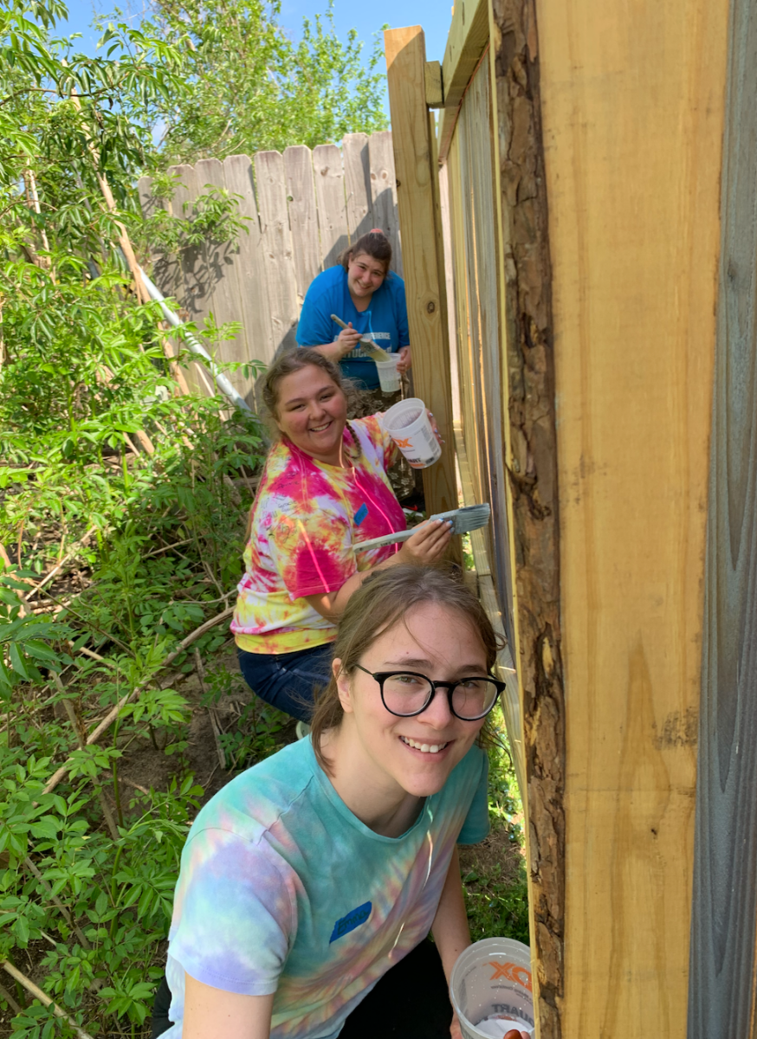
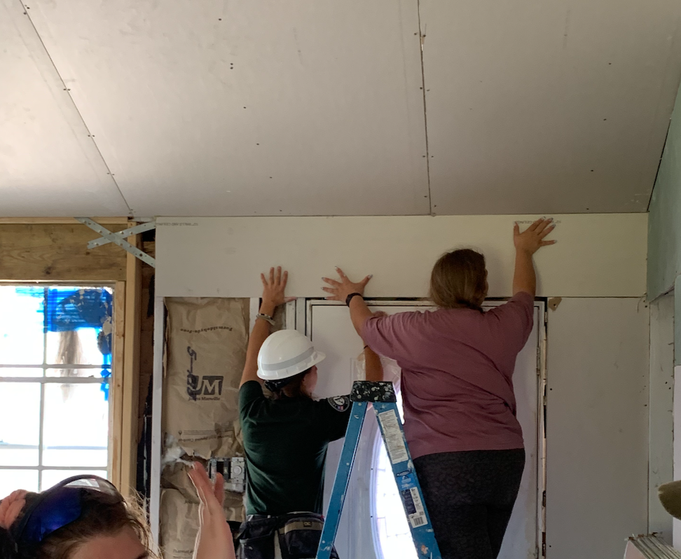
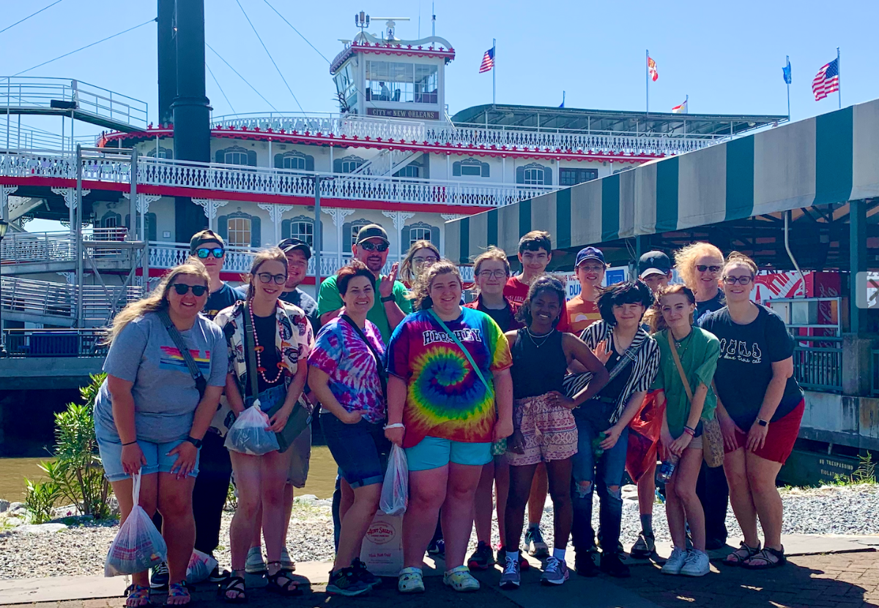

You can find us at:
Facebook: facebook.com/lincolncountyky
Lincoln County 4-H
Website: lincoln4h.org
Facebook: facebook.com/lincolnco4h
Instagram: Instagram.com/lincoln4h/

